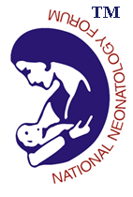

Facility Based Newborn Care Training Program at Raipur

The Government of India is committed to improve the newborn health care and bring a significant decline in the neonatal and infant mortality to meet the Sustainable Development Goals. The Government is planning to operationalize the primary health centers for round the clock deliveries and upgrade the health facilities at the district hospitals and referral centers in terms of inpatient neonatal care.
In this regard, the state of Chhattisgarh has taken a lead and has planned the Facility Based Newborn Care Training program at Raipur with training support from National Neonatology Forum.

Following are the tentative dates for the FBNC training at Raipur:

1. Batch A – 11th March to 14th March, 2020
2. Batch B– 16th March to 19th March, 2020
3. Batch C - 23th March to 26th March, 2020

Note: NNF FBNC faculty is requested to confirm participation as faculty for any one of the above mentioned date on secnnf@nnfi.org&accreditation@nnfi.org latest by 29th Feb. 2020.

Thanks & Regards
Dr. Lalan Kr. Bharti
Secretary General, NNF

