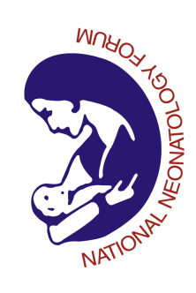

NNF Neonatal Doctor’s Fellowship October Examination 2019
Theory Paper 2 Roll No ______________

All questions are compulsory

- Duration 3 hours Maximum Marks: 100
Q1.Discuss the following: 5X10=50
- Neonatal pain: Assessment and management modalities 8
- Counselling of Young Parents who are planning for a second child. Their previous child is having Downs’s syndrome. 8

- Hyperglycemia: Definition, Investigations and management 8
- Transient disorders of thyroid in neonates 8
- Thermal management of a 27 wks preterm with birth wt of 900 gm having axillary temperature of 31⁰ C in NICU. 8
Q.2.Write in brief:
a. HHFNC principle and how it is different from CPAP 5 b.Downe’s and silverman Anderson scores 5 c.Probiotics and NEC in preterms : What is the evidence 5 d.MAA programme 5 e.Epidemolysis bullosa 5 f.Customized Breast milk fortification 5 g.Antenatal steroids for late pretems:Current guidelines 5 h.Stratgies for Placental transfusion at birth 5

Q3. One of the ELBW neonate has grown a multi drug resistant Klebseilla (resistant to meropenem)in NICU. In the same room, there are 3 other ELBW neonates and 4 VLBW neonates. Discuss the containment measures to be initiated and strategies for combating Multi drug resistant Organism in the NICU. 10

Q4.Write short notes on:
a. Lung protective strategies in neonatal ventilation 5
b. Pharmacological management of PDA 5

.

